3. Water Jug Problem
Aim
To solve the Water Jug Problem using Breadth-First Search (BFS) and obtain the required amount of water.
Algorithm
- Define the capacities of both jugs.
- Start with both jugs empty.
- Generate all possible states:
  - Fill Jug 1
  - Fill Jug 2
  - Empty Jug 1
  - Empty Jug 2
  - Pour water from Jug 1 to Jug 2
  - Pour water from Jug 2 to Jug 1
- Mark visited states.
- Repeat until the target amount is obtained.
- Display the sequence of states.
Pseudocode
Start
Initialize Jug1 and Jug2 as empty
Create a queue and visited list

While queue is not empty
Remove current state
If target is found
Display solution
Stop
Generate all possible next states
Add unvisited states to queue
End While

Stop

Code:
from collections import deque

def water_jug(jug1, jug2, target):
visited = set()
queue = deque([(0, 0)])

while queue:
x, y = queue.popleft()

if (x, y) in visited:
continue

visited.add((x, y))
print((x, y))

if x == target or y == target:
print("Target reached!")
return

next_states = [
(jug1, y),
(x, jug2),
(0, y),
(x, 0),
(max(0, x-(jug2-y)), min(jug2, x+y)),
(min(jug1, x+y), max(0, y-(jug1-x)))
]

for state in next_states:
if state not in visited:
queue.append(state)

water_jug(4, 3, 2)

Output:
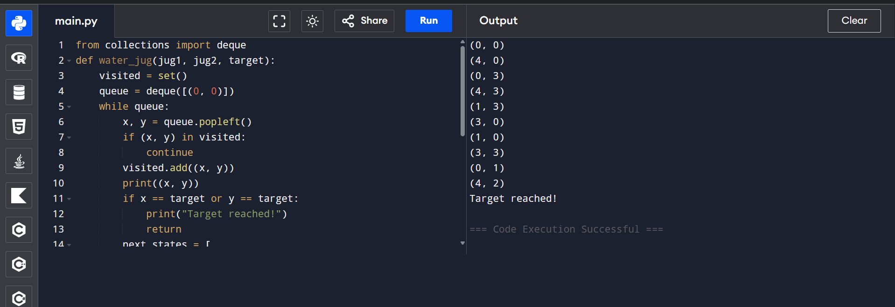

4. Crypt-Arithmetic Problem
Aim:
To solve the Crypt-Arithmetic Problem by finding digits that satisfy the given equation.

Algorithm:
- Take the words in the equation.
- Assign unique digits (0–9) to each letter.
- Ensure no two letters have the same digit.
- Check whether the arithmetic equation is satisfied.
- If true, display the solution.
Pseudocode:
Start
Take the words
Assign digits to letters
Check if equation is correct
If correct
Display solution
Else
Try another assignment
Stop

Code:

from itertools import permutations

letters = ('S','E','N','D','M','O','R','Y')

for p in permutations(range(10), 8):
S,E,N,D,M,O,R,Y = p

if S == 0 or M == 0:
continue

send = 1000*S + 100*E + 10*N + D
more = 1000*M + 100*O + 10*R + E
money = 10000*M + 1000*O + 100*N + 10*E + Y

if send + more == money:
print("SEND =", send)
print("MORE =", more)
print("MONEY =", money)
break

Output:
